

**GRAND ASSIGNMENT**

**PROPOSAL**

***AUGUST 2024***

***PRESENTED BY***

***ALIYAN ADNAN SHAMSI***

***MISS OMEMA***

***PRESENTED TO***

|  |  |  |
| --- | --- | --- |
| **Supervisor** | **MISS OMEMA** | |
| **Batch** | **PR2-2024-02B** | |
| **Group** | **A** | |
| **Serial No.** | **Enrollment Number** | **Student’s Name** |
| **1.** | **Student1551018** | **AYESHA TARIQ** |
| **2.** | **Student1550046** | **FIBHA ATIF** |
| **3.** | **Student1551019** | **HAREEM TARIQ** |
| **4.** | **Student1549184** | **MANAL ABID** |



2023



Table of Contents

CERTIFICATE OF COMPLETION 5

ACKNOWLEDGEMENT 6

PROJECT SYNOPSIS 7

Problems statement 8

FACTIONAL REQUIRMENT 8

HARDWARE AND SOFTWARE REQUIRMENT 9

WEBSITE FEATURES 9

USER’S GUIDE 10

HOME PAGE: 10

ABOUT US: 14

GALLERY 16

FAQ’S: 17

CATEGORIES OF HANDICRAFTS 18

BRASS HANDICRAFT 18

CANDLE ACCESSORIES 19

SITE MAP 20

DEVELOPER’S GUIDE 22

NAVBAR: 22

SLIDER: 24

FOOTER: 25

FLOW DIAGRAM 26

TASK SHEET 27

HANDICRAFT PRODUCTS

* IRON HANDICRAFTS
* GLASS HANDICRAFTS
* CANDLE ACCESSORIES
* HOME DECOR
* TABLE WARE
* BRASS HANDICRAFTS
* DECORATED HANDICRAFTS
* ALUMINIUM HANDICRAFTS
* WOOD HANDICRAFTS

DETAIL OF PRODUCT

# CERTIFICATE OF COMPLETION

**This is to certify that, AYESHA, FIBHA, HAREEM and MANAL have successfully completed  
their ACCP Prime2.0**

**Semester I E-Project.**

**Submitted to: Aptech Computer Education**

**On**

**10 August 2024**

# ACKNOWLEDGEMENT

**First of al0Xl we would like to thank Almighty Allah for giving us strength and ability to complete this project  
  
And then, we would like to express my special thanks of gratitude to our teacher MISS OMEMA who guided us on the project *Handicraft,* which also helped us in doing a lot of new learning and we came to know about so many new things we are really thankful to her.**

**We are highly thankful to MISS OMEMA for her guidance and constant supervision well as for her support in completing the project**

**Lastly, we would also like to thank our parents and friends who helped us a lot in finalizing this project within the limited time frame. We also express our sincere gratitude to I-Project team from Aptech Head Office, for their valuable guidance and support for the completion of this project. We earnestly hope that this project will provide all the necessary information required by the user to fulfill his/her inspiration. However, suggestion and Feedbacks for improvements will be thankfully welcomed & acknowledged.**

# PROJECT SYNOPSIS

**We provide most creative & unique Handicrafts for you.**

**A handicraft, sometimes more precisely expressed as artisanal handicraft or handmade, is any of a wide variety of types of work where useful and decorative objects are made completely by one’s hand.**

**Handicrafts is famous for handmade great variety. It provides collection of number of products with different category to match the healthy, luxury life of the generation. In order to enhance our business we have a lot of variety in products.**

# Problems statement

**Venus Handicrafts is certified company engaged in manufacturing and exporting of Decorative Handicrafts to global importers, wholesalers and retailers since 1972. The ever-increasing acceptance of our products on global platform highlights our market presence and goodwill. The company has maintained its market value throughout the world. To enhance its value the organization wants to change the look and feel of the website for which they have approached you.**

# FACTIONAL REQUIRMENT

**The Website is to be created based on the following requirements.  
1) The Home Page should be created with proper sections, graphics and with a suitable logo**

**2) Link on the home page must be included such as Home, About us, Gallery, Contact information, Handicrafts products,**

**3) The look and feel of the project must be made user friendly and uniformity in the color combination must be maintained.**

**4) Handicrafts such as:**

**- Iron Handicrafts**

**- Glass Handicrafts**

**- Brass Handicrafts**

**- Wood Handicrafts**

**- Aluminum Handicrafts**

**- Handicraft Decorative**

**- Tables wares**

**- Home Décor**

**- Candle Accessories**

**5) Navigation of the project must be made smooth.**

**6) Gallery**

**7) FAQs**

# HARDWARE AND SOFTWARE REQUIRMENT

**Hardware**

* **A minimum computer system that will help you access all the tools in the course is Pentium 166 or better.**
* **64 Megabytes of RAM or better.**

**Software [Either or Combination as per Course/Sem]**

**• Notepad/HTML editor/CoffeeCup**

**• Angular / Angular JS / React / BootStrap**

**• Dreamweaver / Figma**

**• MS IE / Chrome / Firefox / Netscape /MS Edge**

# WEBSITE FEATURES

**This website Handicrafts-the online store, contains almost all of the handicraft’s products and a lot of variety of handicrafts are present in handicrafts. So, the development of this website gives people to purchase iron handicrafts, brass handicrafts, decorative handicrafts, aluminum handicrafts, home décor items, wood handicrafts, glass handicrafts, candle accessories and much more by single click.**

**This site contains pictures and description along with their prices of all those products which they were selling in their store.**

# USER’S GUIDE

# HOME PAGE:

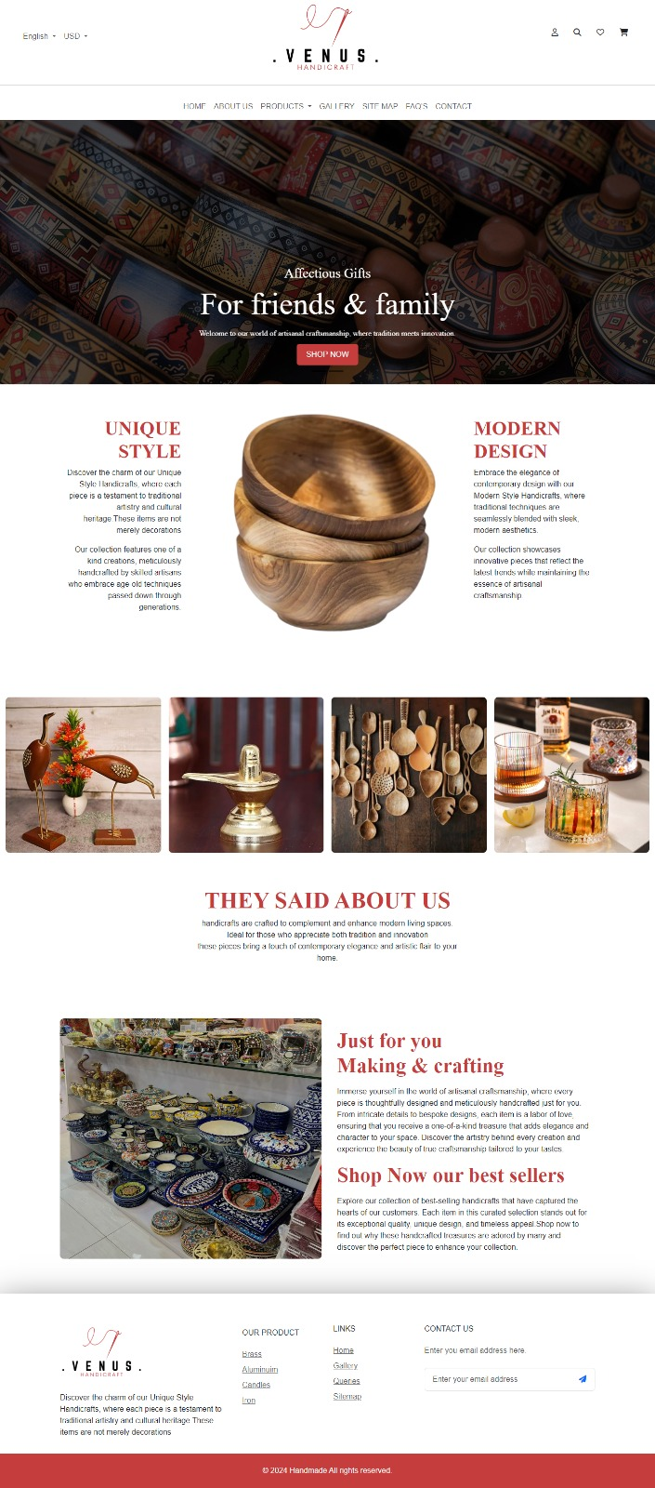

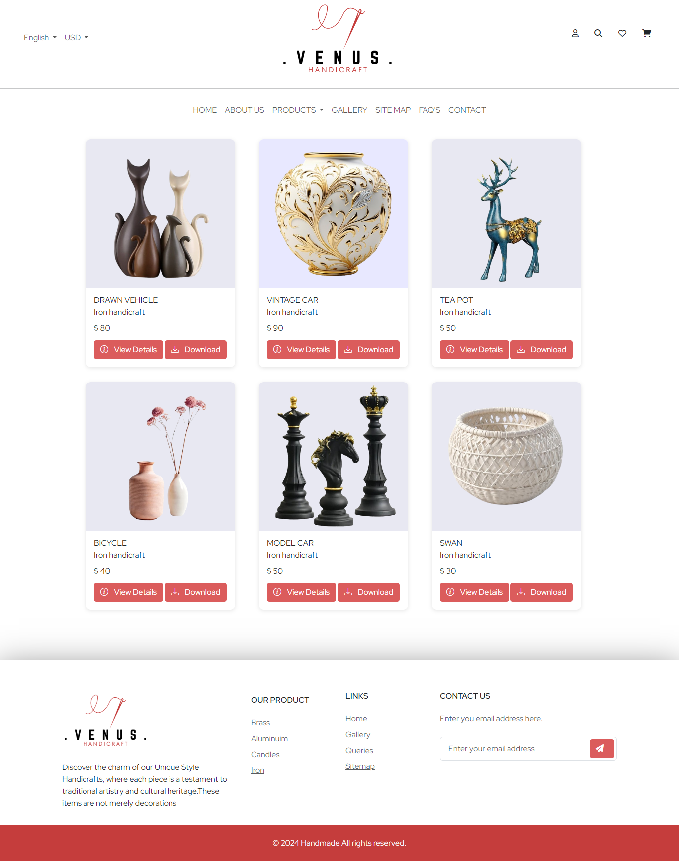

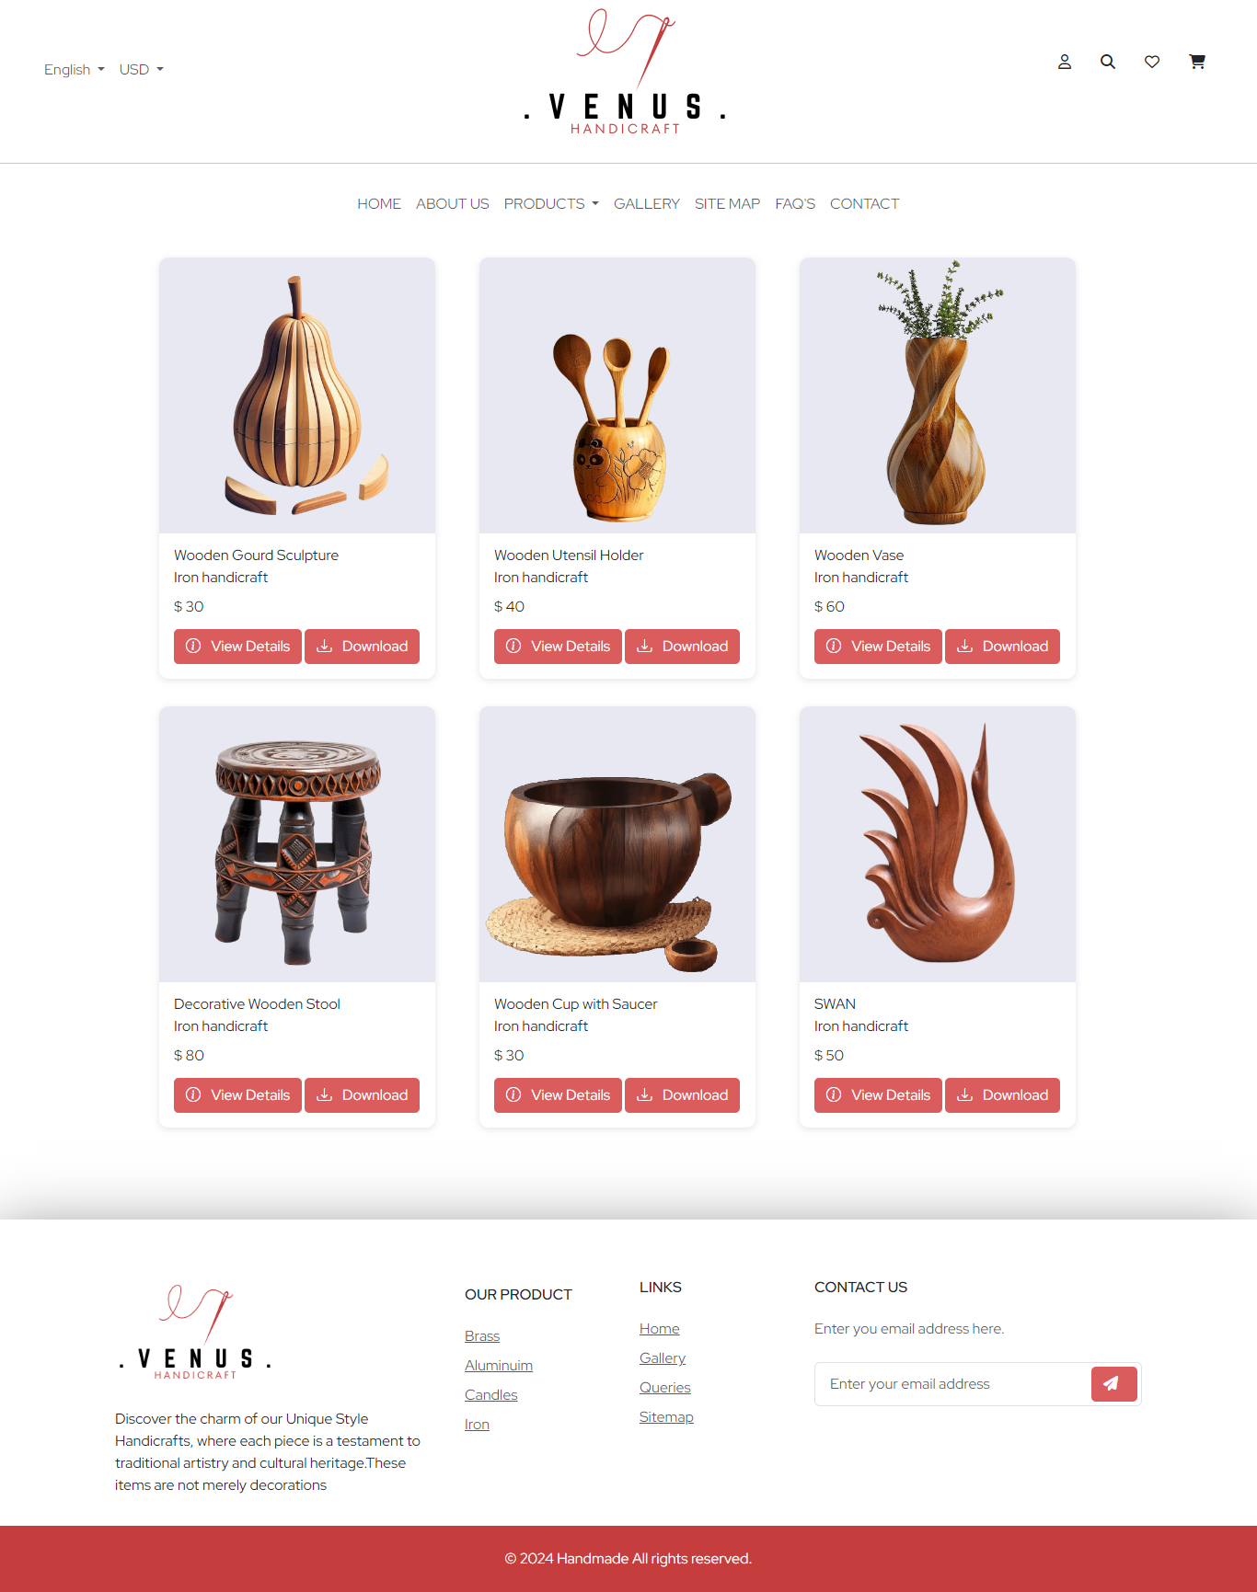

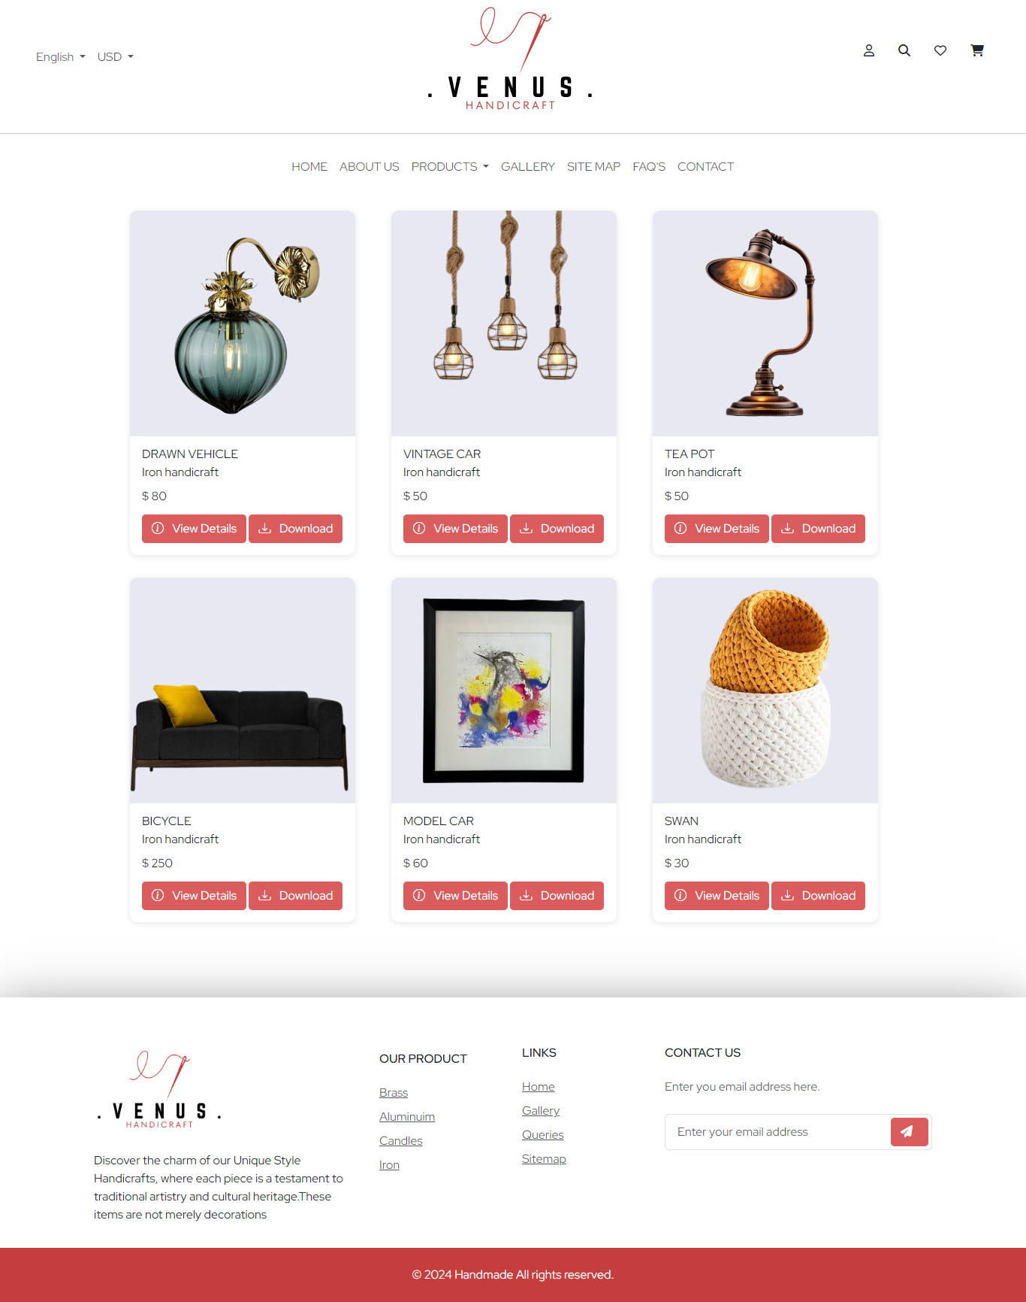

# 

# ABOUT US:

**CONTACT US:**

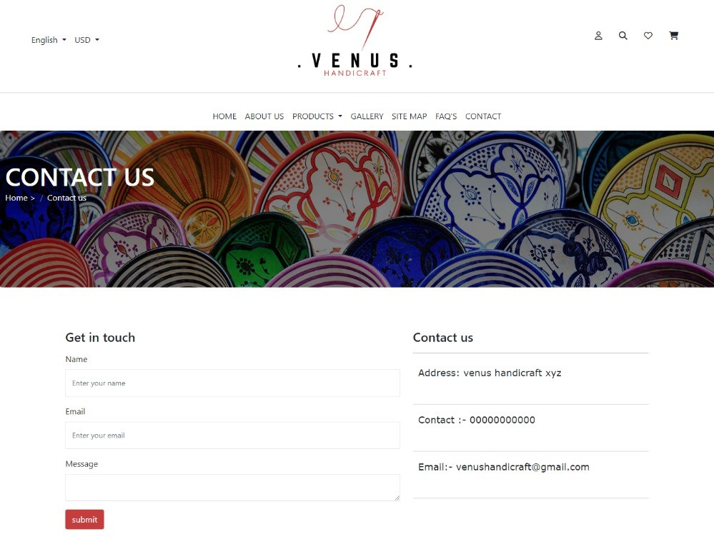

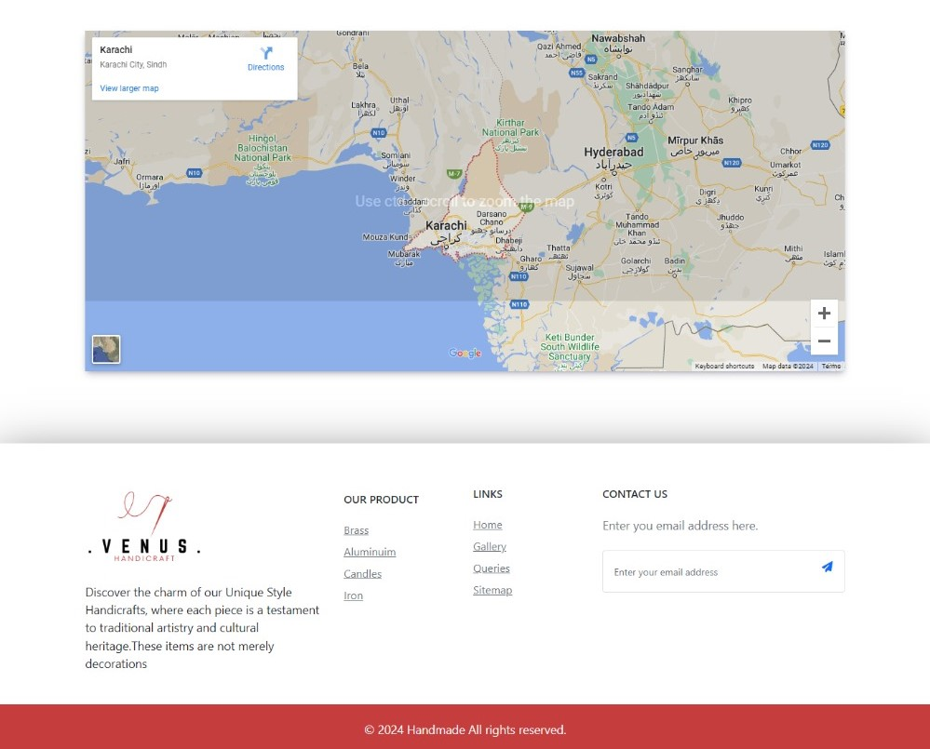

GALLERY**:** 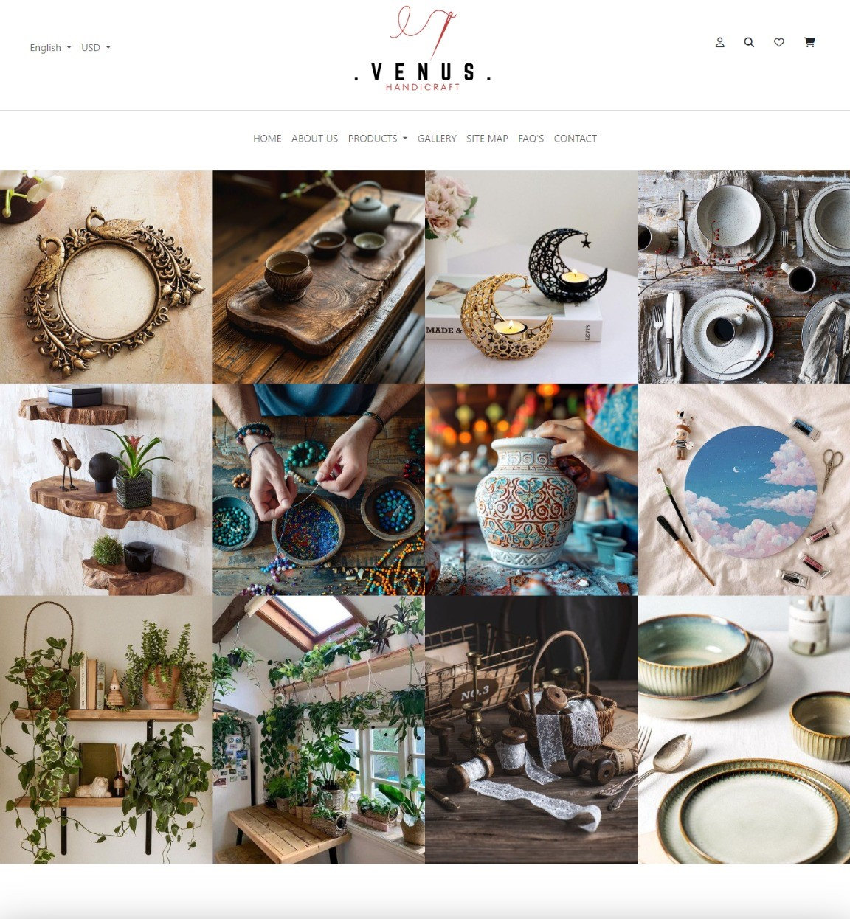

# FAQ’S:

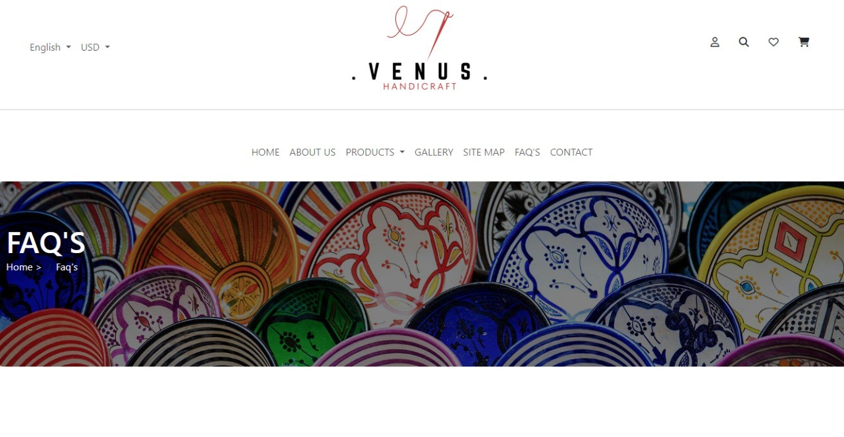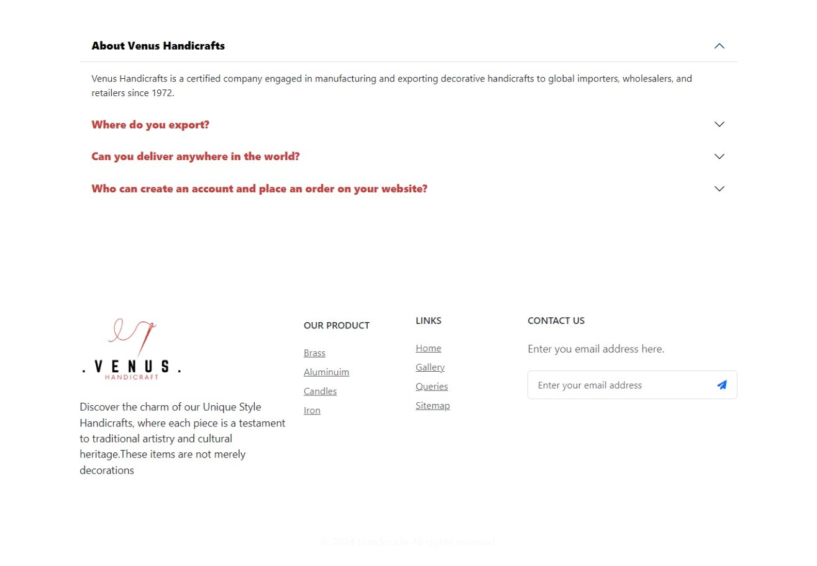

# CATEGORIES OF HANDICRAFTS

# BRASS HANDICRAFT

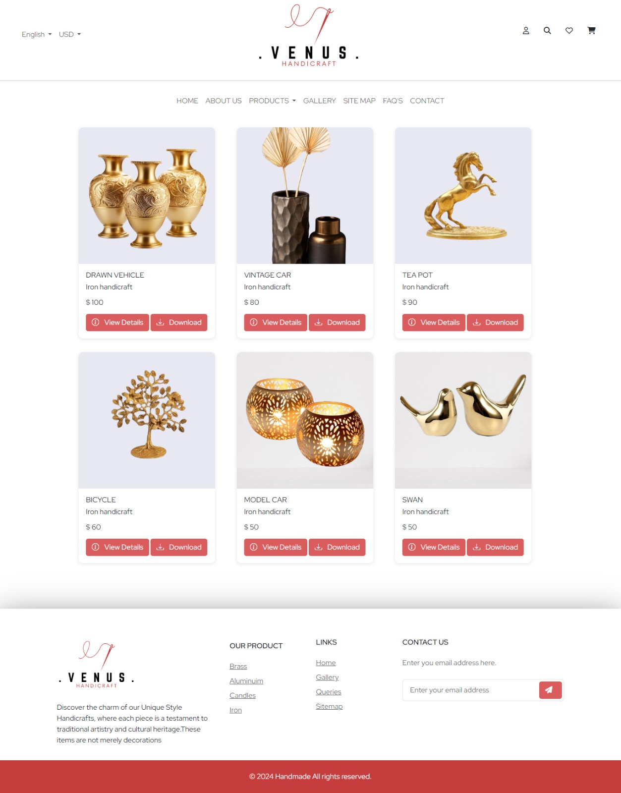

# CANDLE ACCESSORIES

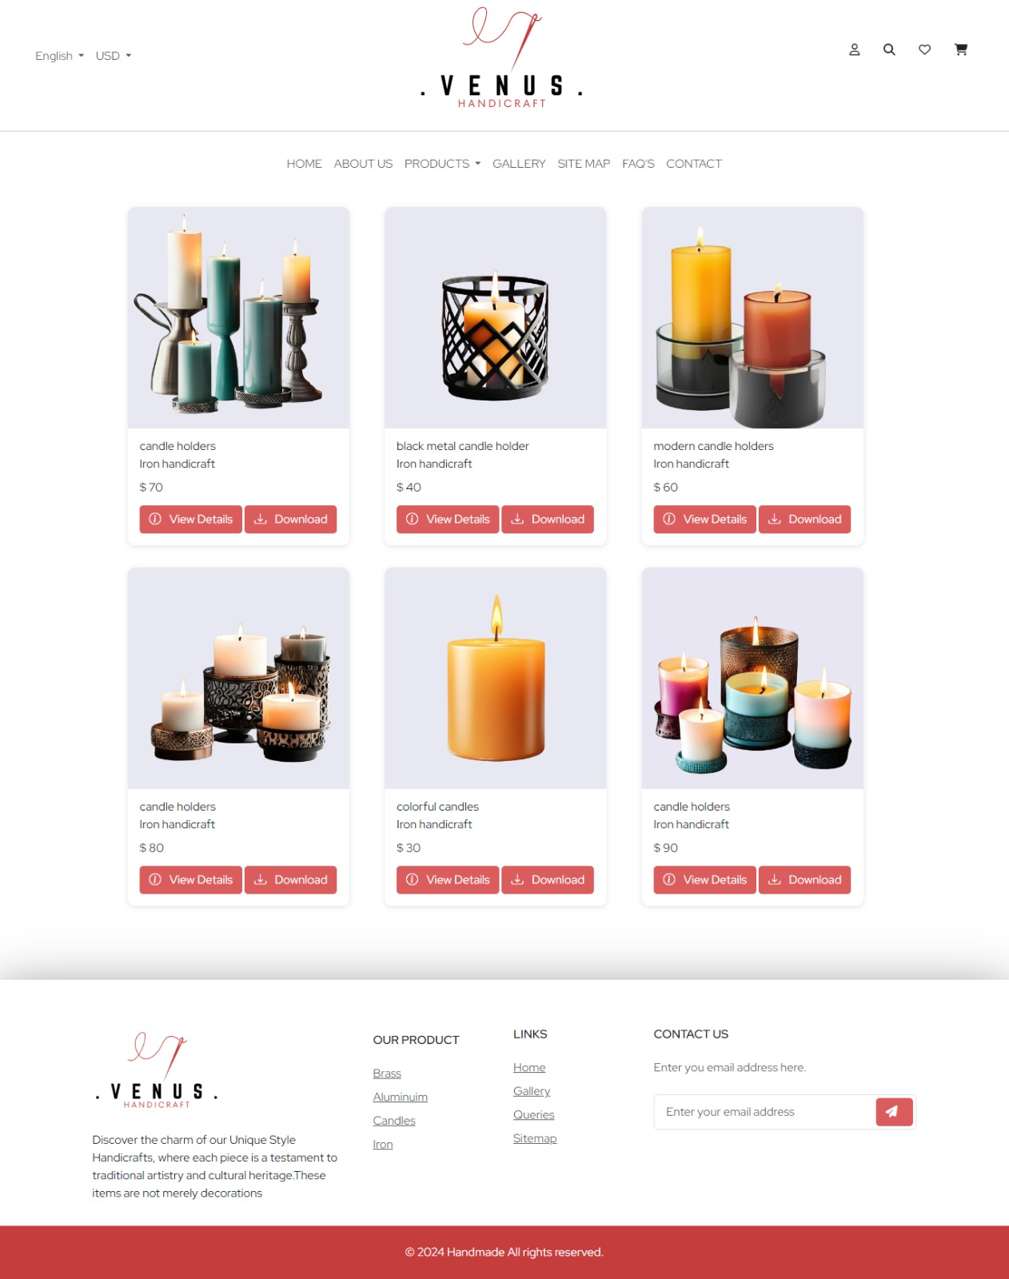

# SITE MAP

# 

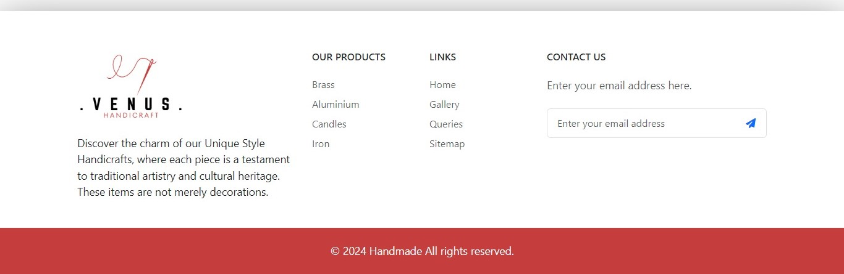

# DEVELOPER’S GUIDE

# NAVBAR:

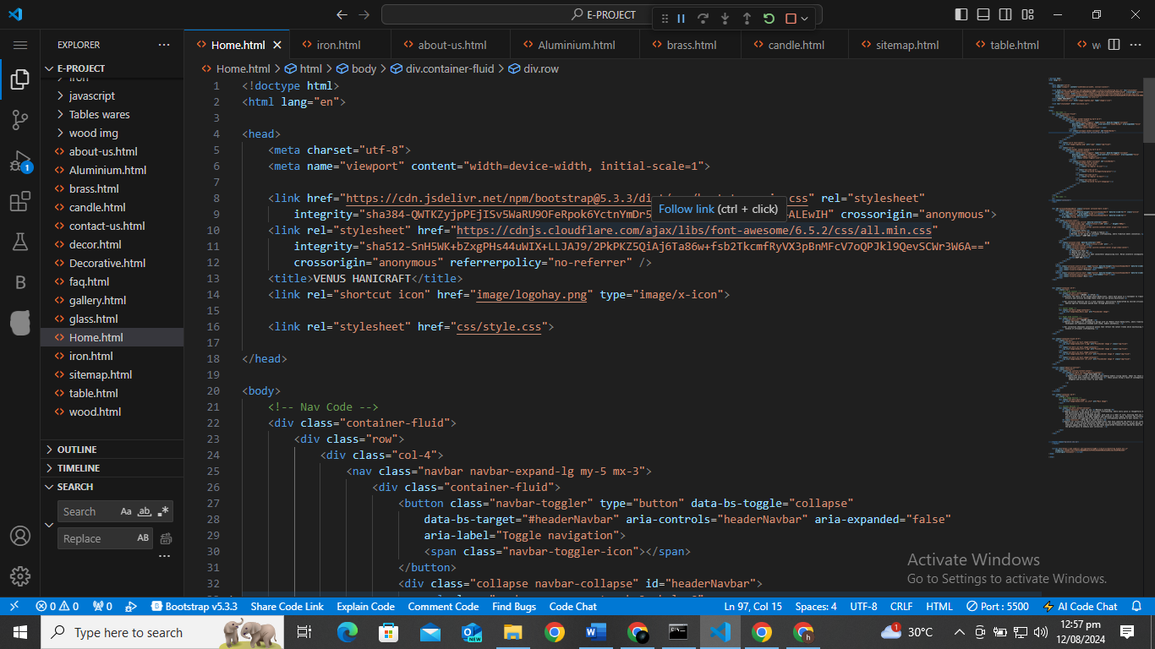

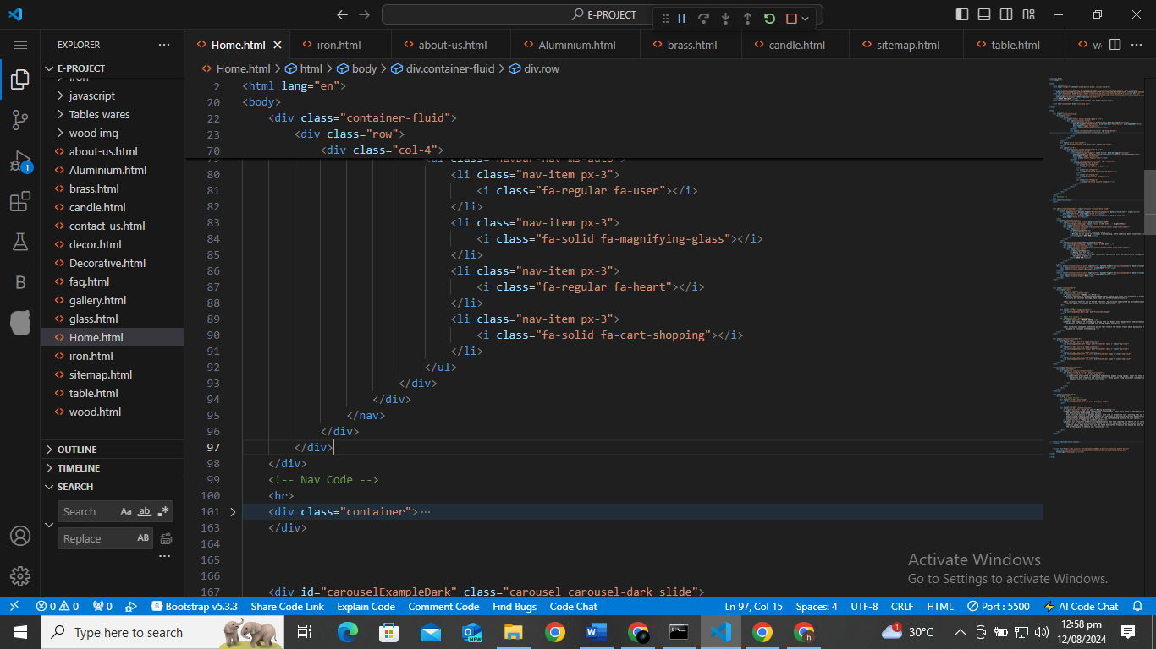

# SLIDER:

# 

# 

# FOOTER:

# 

# 

# FLOW DIAGRAM

# TASK SHEET

|  |  |  |  |  |
| --- | --- | --- | --- | --- |
| **Project Ref. NO.** | | **Project Title** | **Date of Preparation of Activity Plan** | |
|  | | | | |
| **S.No** | **Ta** |  | **Actual**  **Days** | **Status** |
|  | | | | |
| **1** | **Analysis** | **Handicrafts** | **1** | **OK** |
| **2** | **Design** | **4** | **OK** |
| **3** | **Development** | **7** | **OK** |
| **4** | **Testing** | **1** | **OK** |
| **5** | **Documentation** | **1** | **OK** |
|  | | | | |